Instructions and Formatting Rules for Authors
First author¹, Second author², Third author³ (Times New Roman 11pt)
¹First author affiliation, University/Institute (Times New Roman, 10pt); Email address (9pt)
²Second author affiliation, University/Institute (Times New Roman, 10pt); Email address (9pt)
³Third author affiliation, University/ Institute (Times New Roman, 10pt); Email address (9pt)
* Corresponding author: Name

abstract
In this manuscript, basic instructions for the preparation of a paper are provided. This document is an example of the desired layout and can be used as a template. The document contains information on all required styles, type sizes, and typefaces. The English abstract is limited to 150 to 300 words in one paragraph. It should concisely state the subject or problem, the methodology, the principal results, and their significance.

Keywords: Up to 6 Words, Separated by Comma.

Note: If you intend to submit only the abstract to the conference, please place and submit your abstracts in the designated abstract section.

Introduction
This instruction gives you guidelines for preparing papers. All papers must be submitted electronically in Docx format. Prepare your paper in A4 page size of 210 mm × 297 mm (8.27" × 11.69"). The length of your paper should not exceed 20 pages.
Set the top margin to 1.5" and the bottom margin to 0.5". Left and right margins should be 0.59" and gutter 0. Header and footer 0" and 0.5", respectively. Use a single-column format and single spacing.

Article Structure
The article should include the following sections:
Article Title
Name(s) of the Author(s) (without using titles such as Mr., Dr., etc.)
Abstract
1. Introduction:
Include the background and perspective on the topic and its importance, a brief review of existing scientific foundations, the study objective, and the rationale for conducting the research.
2. Theoretical Framework and Research Background
3. Research Methodology
4. Data Analysis (Findings)
5. Discussion, Conclusion, and Recommendations (Highlighting the strengths, limitations, and applications of the research)
References

In-text Citations
In in-text citations, when a cited source has two or more authors, the surnames of all authors, the year of publication, and then the page number (if the material is a direct quotation) should be provided throughout the text (and also in the reference list). For example:
“Textbooks are written to teach basic principles and fundamental concepts in specific disciplines and to prepare students for higher levels of education” (Sheikh & Abbasi, 2014, p. 69).
For citations covering more than one page, the abbreviation pp. is used.
- Direct quotations exceeding forty words should be presented as a separate block, indented (0.5 cm) from the right margin, using B Nazanin font, size 10. For indirect quotations, quotation marks and page numbers are not required.
- Titles of books and journals should be italicized in the text, while the titles of articles, poems, and short stories should appear in quotation marks.
- For works with more than two authors, only the surname of the first author is mentioned, followed by the phrase “et al.” (Ahmadi et al., 2024).
- When multiple works by one or more authors published in the same year are cited, lowercase letters (a, b, c, …) are added immediately after the year of publication in in-text citations. In the reference list, each work is listed separately and in order with its corresponding letter suffix.
- For electronic sources without page numbers, the paragraph number is cited if the text includes paragraph numbering. If the online text has neither page numbers nor paragraph numbers, the citation should refer to the subsection title and the paragraph number within that subsection.
- If the same source is cited repeatedly in consecutive instances, the author’s surname, year, and page number must be mentioned each time, and the term “ibid.” should not be used. It should be noted that excessive reliance on a single source is not recommended.
- When several sources are cited at the end of a sentence, they are separated by semicolons (;) and ordered alphabetically (Baudrillard, 2005; Bailey, 2012).
- When a statement by an individual is quoted from a secondary source, only the name of the original individual is mentioned in the text, and the details of the secondary source are provided after the phrase “as cited in”. For example:
Plutchik presented a three-dimensional model to describe the relationships among emotions, and … (as cited in Yat Mealy, 2019).
- If footnotes are required, they should be written left-aligned, using Times New Roman font, size 9, in regular (light) weight.

Figures and Tables
All of the Tables and Figures must be in the center of the page. The title of the Tables must be at the top of the Table and the title of the Figures must be below them at the center. Insert figures and tables after they are cited in the text.
Table 1.
Table type styles
Subject | Font | Size | Type
Paper Title | Times New Roman | 14 | Bold
Name and Family of Authors | Times New Roman | 11 | Bold
Affiliation of Authors | Times New Roman | 10 | Normal
Section Title | Times New Roman | 12 | Bold
Section Subtitle | Times New Roman | 11 | Bold
Abstract text | Times New Roman | 11 | Normal
Keywords | Times New Roman | 11 | Normal
Body text | Times New Roman | 11 | Normal
Footnotes | Times New Roman | 9 | Normal
Title of Tables and Figures | Times New Roman | 10 | Normal
Text of Tables | Times New Roman | 10 | Normal
References | Times New Roman | 11 | Normal
- Sample of a Table footnote. (Table footnote)

Figure 1.
Emotions
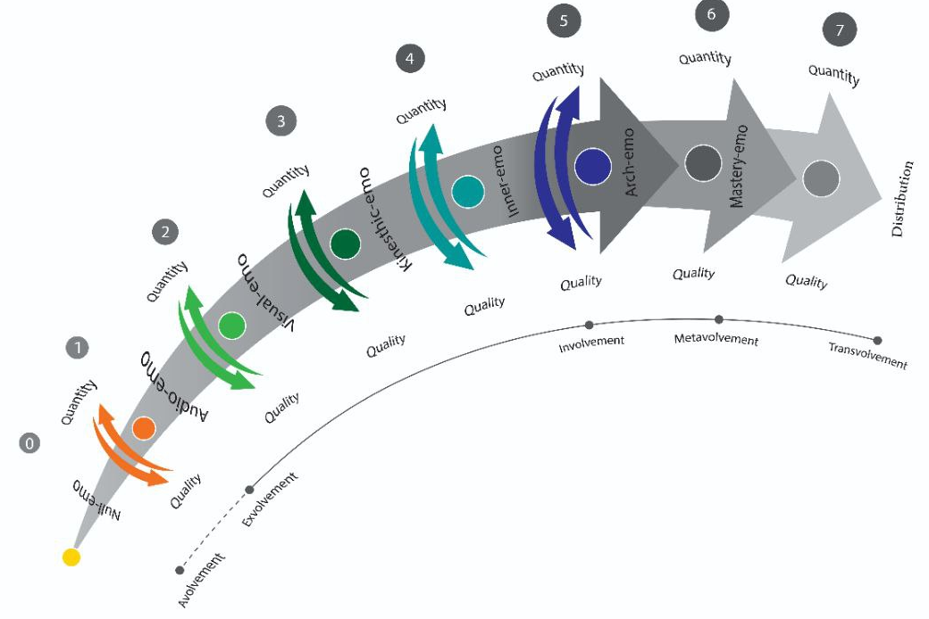

Discussion and Conclusion

In the conclusion, the study's key points and primary outcomes should be summarized concisely. In the first paragraph of this section (the Discussion part), the researcher should compare their findings with those of other researchers and clarify the extent to which their results are consistent with or contradictory to previous studies. In the second paragraph, recommendations and suggestions should be presented.

Acknowledgments
Identify grants or other financial support (and the source, if appropriate) for your study. Thanks to those who helped with the preparation of the article indirectly.

References
All references should be formatted according with the American Psychological Association (APA) style (7th). In-text citations usually provide the name of the author(s) and the year the source was published. Refrain from numbering the references inside the separate text.
Behrooz, S. (2017). Designing a new measure of text readability in light of emotions: A reader-based view (Unpublished, master's thesis). Ferdowsi University of Mashhad, Mashhad, Iran.
Bošković, Ž. (2004). Object shift and the clause/PP parallelism hypothesis. In B. Schmeiser, V. Chand, A. Kelleher, & A. Rodriguez, (Eds.), Proceedings of the 23rd West Coast Conference on Formal Linguistics (pp. 101-114). Cascadilla Press.
Greenspan, S., & Weider, S. (1998). The child with special needs: Intellectual and emotional growth. Perseus Publishing Encouraging.
Pekrun, R. (2006). The control-value theory of achievement emotions: Assumptions, corollaries, and implications for educational research and practice. Educational Psychology Review,18 (1), 315-341.

